COLDFALL WOOD

LONDON BOROUGH OF HARINGEY

A geo-archaeological evaluation of an ancient ditch and bank.
Revised June 2020

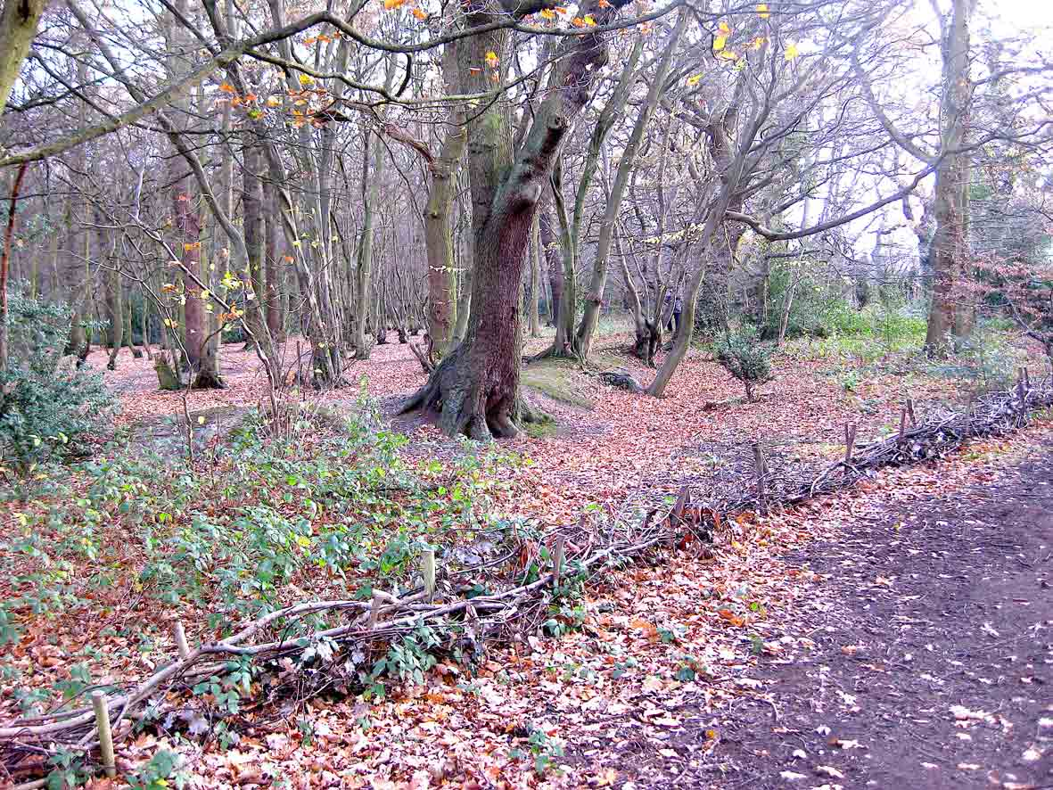

Coldfall Wood.
Western boundary bank.

Michael Hacker
London
June 2012
COLDFALL WOOD
London Borough of Haringey

A geo-archaeological evaluation of an ancient ditch and bank.

Site code: CFW12
OS grid reference: TQ 2748.9038
Height above OS datum: c.80m OD

Contents

Summary
Introduction
Background
The boundary bank
Geology
Archaeological evaluation
Pollen analysis [Prof. Rob Scaife-University of Southampton]
Dating
Interpretation
Conclusions
Suggestions for further work
Acknowledgements
Bibliography

Illustrations

Frontispiece: Western boundary bank.

Fig 1: Coldfall Wood, Haringey in relation to Greater London.
Fig 2: Coldfall Wood overlaid on 1873 OS survey.
Fig 3: Part of Thomas Milne’s Land use map of London and Environs.
Fig 4: Location of evaluation trench.
Fig 5: Machine cut trench across the ditch and bank.
Fig 6: Section across the ditch and bank.
Fig 7: Hypothetical reconstruction of the ditch and bank.
Fig 8: Part of section of bank showing location of soil samples.
Fig 9: Pollen diagram.
.

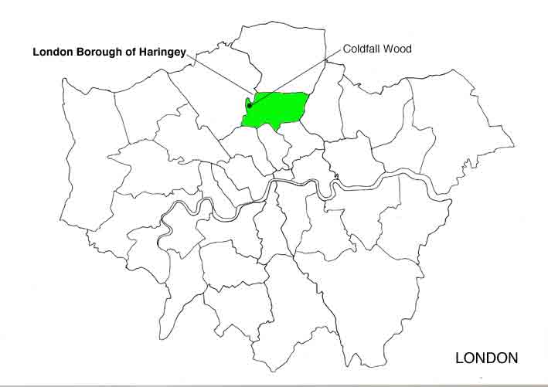

Fig 1: Coldfall Wood, Haringey, in relation to Greater London

Summary

- Coldfall Wood is an area of ancient woodland dominated by mature hornbeam and oak standards.

- It is bounded on its western and northern boundaries by a ditch and bank feature. Documentary evidence suggests that it is ancient. Archaeological evidence for the date of its construction and the nature of the woodland at the time of its construction has not previously been evaluated.

- In the summer of 2012 an opportunity arose to carry out an archaeological evaluation of the ditch and bank feature. The evaluation was carried out by members of the Hendon and District Archaeological Society (Michael Hacker, Geraldine Missig and Emma Robinson). Prof. Rob Scaife, University of Southampton, carried out pollen analysis of soil samples.

- At the time of the evaluation samples had been taken of a soil buried under a similar bank in the nearby Queen’s Wood. These were subject to pollen analysis. This indicated that the banks in Coldfall Wood and Queen’s Wood were constructed at about the same time. Soil samples from Queen’s Wood were dated by radiocarbon analysis. This has enabled a date to be established for the construction of the banks.

The evaluation has established that:

The ditch and bank boundary was constructed to enclose the wood in the latter half of the 16th Century.

At the time the bank was constructed, the wood was open, mixed deciduous woodland dominated by oak standards and hazel. It was situated in a mixed landscape of heath, pasture and cultivated land.

The form and size of the bank and ditch feature is consistent with it being constructed to protect the wood from deer, other grazing animals and trespassers.
Introduction

Coldfall Wood is owned by the London Borough of Haringey. It is located c.10km (c.6miles) due north of central London (Charing Cross) (Fig 1.).

The history of Coldfall Wood is summarised in Haringey Council’s management plan for 2012.

“Coldfall is one of four woods in Haringey which are almost certainly ancient, the others being Queen’s, Highgate and Bluebell Woods. The history of three of these woods is detailed in a paper by Silvertown (1978); only a very brief summary is given here.

Humans have greatly altered the composition and structure of Coldfall Wood, but it is likely that it has been continuously wooded since prehistoric times; pollen analysis from a site on Hampstead Heath, a few miles away, shows the first appearance of cereals and weeds of cultivation around 3,000 BC. The wood was probably managed as coppice from at least Roman times onwards. In about 1650 Coldfall Wood was all but surrounded with common land and was apparently subject to the rights of commoners to pasture their animals. However, grazing animals would damage the woodland if allowed in too often or too soon after cutting, and the wood was protected by a bank with a ditch on its outside. These ancient defenses still survive along the northern and western boundaries of the wood, all the more extraordinary considering the wood's position well within a major city.”.

Coldfall Wood is recognised as an area of ancient woodland, i.e. it has been continuously wooded at least since 1600.. It is managed by the London Borough of Haringey with help from a voluntary community group, ‘The Friends of Coldfall Wood’. The wood is currently (2020) closed canopy, mixed, deciduous woodland dominated by mature hornbeam (Carpinus sp.) with occasional oak standards (Quercus sp.).

Background

Coldfall Wood once formed part of the Bishop of London’s extensive holdings of woodland in this part of north London. These included the nearby Highgate and Queen’s Wood. Documentary records indicate that the land occupied by these woods had formed part of the Bishops’ estates from Saxon times.

Between 1647 and 1660 the Bishops lost possession of the manor and the Commonwealth sold the Bishops’ lands to Sir John Wollaston (d.1643), a city merchant and alderman..

Following the Restoration (1660) the Bishops leased the land to a series of lessees at least from 1685. In 1868 the land was passed to the Ecclesiastical Commissioners who continued to lease the land. The last lessee was William Murray, later earl of Mansfield of Ken Wood. In 1885 the earl’s trustees sold their rights back to the Ecclesiastical Commissioners.

The Bishop’s woods in Hornsey were an important element of the estate and would have provided a source of timber and firewood. Coldfall Wood is referred to in some documents and maps as Coalfall or Colefall Wood, indicating that it may have been used for charcoal production.

Documentary evidence indicates that the Bishop’s woods were managed woodland with a coppiced understory, providing firewood in the form of faggots and timber from oak standards. Of 15 trespassers in the park in 1318, 13 had felled oaks and one had taken 600 faggots. In 1406 the chapter of St Paul’s took 32 spars for the belfry of St Paul’s cathedral and 1,000 faggots of firewood. In 1464 the bishop’s palace was supplied with 4,000 faggots. In 1579 Bishop Aylmer (1521-1594) admitted to selling 800 trees.

In the mid 16th century the government became concerned that the overexploitation of woodlands threatened the essential supply of timber and firewood. Malcolm Stokes notes that ‘Great Colefall (alias Coalfall or Coldfall Wood) was enclosed by the bishop in 1543 by Act of Parliament.’. This is a reference to a bill passed during the reign of Henry VIII, ‘The bill for the preservation of woods ’(1543). This required managed woodland to be enclosed and protected from deer and other grazing animals for a period of seven years after coppicing.

Prior to this, the enclosure of the woodland on Finchley Common by the Bishop in the early sixteenth century had lead to a long running dispute with the people of Finchley over their commoner’s rights:

‘In 1533 Finchley men asserted their traditional right to 'cooltes' for swine in Finchley wood, which they said had been destroyed by the bishop's woodward, who had also taken away their hedging bills. In 1562 they defended their claim to common of pasture 'from time immemorial' against the lord's proposal to divide and separate a quarter of his woods. Judgment was given for the bishop, in accordance with the Act of 1543 for the preservation of woods (35 Hen. VIII, c. 17). Possibly Great Colefall (later Coldfall) was the quarter so inclosed: when it was leased in 1645 with the other demesne woods it was called 'the wood in Finchley common'.

This account refers to the dispute being with the people of Finchley rather than the people of Hornsey, which suggests that at that time Coldfall Wood was regarded as being part of Finchley. Malcolm Stokes has demonstrated that the present boundary between Finchley and Hornsey was not established before 1816 .

The boundary bank

A prominent ditch and bank feature runs close to western boundary and part of the northern boundary of the wood. It has been assumed that this is a remnant of the boundary provided to enclose and preserve the wood following the judgment of 1562. Such protection usually took the form of a bank surmounted by a pale or hedge with a ditch on the outer side together with a track to provide access to clean the ditch and maintain the hedge.

The bank had not previously been securely dated or subject to archaeological evaluation. A topographical survey of a number of similar ditch and bank features in Highgate Wood concluded that the features were possibly of medieval or earlier date. However, an evaluation of evidence obtained from an archaeological excavation of a section of one of the bank and ditch features concluded that it was associated with a series of 19th century cart tracks.

The bank is c.16m to the east of the present metal fence boundary of the wood. This marks the boundary between the London Borough of Haringey and the London Borough of Barnet. The land to the west of the boundary fence, now municipal allotment gardens, was formerly part of Finchley Common.

The present Coldfall Wood with an area of c.14ha (c.34.6 acres) is a remnant of a much larger wood. The 1896 Ordinance Survey map shows that the wood once extended south to Fortis Green and east almost to Tetherdown and Coppetts Road with a total area of c.42ha (c.103 acres). It is likely that the protective ditch and bank ran round the full perimeter of the wood of c.2.5 km (c.1.5 miles) (Fig 2). Such an enclosure represents a significant financial investment and is indicative of the value attributed to the enclosed woodland and its products.

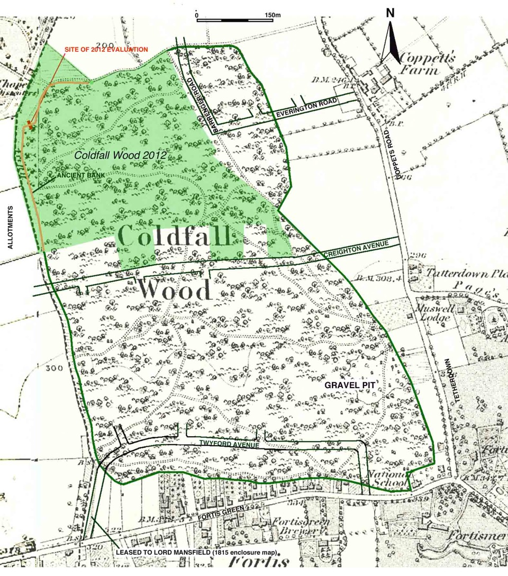
2: The present extent of Coldfall Wood overlaid on 1873 OS survey showing the extent of the wood in the early 19th century.
Coldfall Wood is indicated on a late 18th century land use map by Thomas Milne. It is based on a survey carried out between 1795 and 1799 and shows the extent of the wood and the nearby Queen’s and Highgate Woods at that time (Fig 3.).

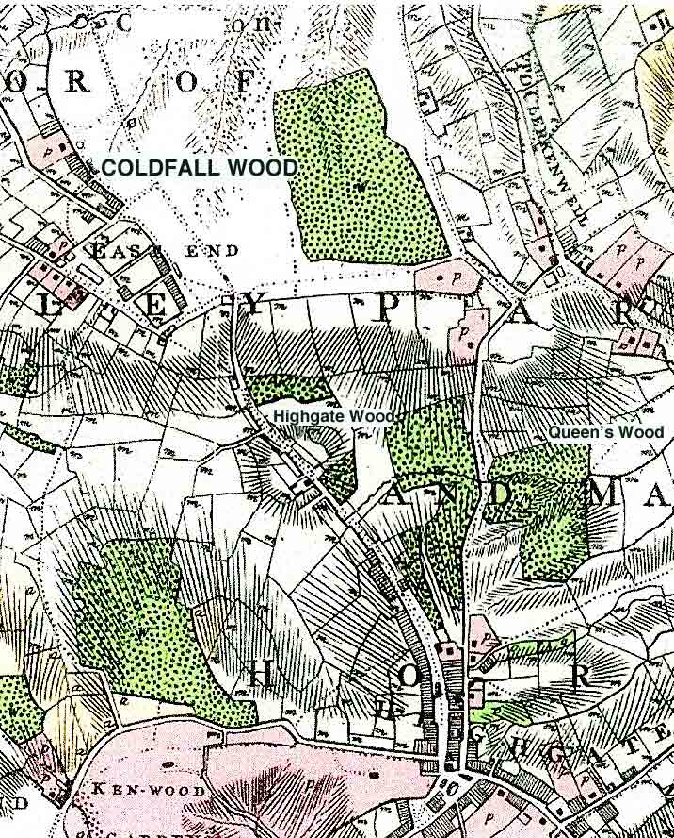

Fig 3: Extract from Thomas Milne’s Land use map of London and Environs -1800, showing Coldfall Wood and the nearby Highgate and Queen’s Wood. .

Milne’s map of 1800 (Fig 3.) and the enclosure map of 1815 show Finchley Common extending to the west and north of the wood. The wood was separated from Fortis Green and Tetherdown by wasteland.

The area of secondary woodland between the western part of the bank and the allotments, which includes ‘Lovers Lawn’, marks the line of a track from Fortis Green which would have provided access to the wood and access to the ditch and bank for maintenance. (see Fig 2, fig 4 and frontispiece).

When the wasteland fronting Fortis Green was enclosed and leased off as individual plots for building development, the westernmost plot was leased to Lord Mansfield, the then lessee of the wood. This would have ensured access to the wood from Fortis Green. It is now occupied by the western part of Twyford Avenue where it joins Fortis Green (see Fig 2).

Geology

The underlying solid geology is the Eocene London Clay Formation. The British Geological Survey indicates that in parts of Coldfall Wood and the immediate surrounding area the London Clay Formation is overlaid by the pre-Anglian Dollis Hill Gravel, a fluvial (river) deposit laid down by a tributary of the ancestral Thames. This river, the Proto Mole/Wey River, once flowed in a northeasterly direction from the Weald towards the Vale of St Albans. Chalky ‘boulder clay’ (Glacial Till) deposited by the Anglian ice sheet c.450,000 BP, caps the gravel on the high ground of Muswell Hill to the south of Coldfall Wood.

The Dollis Hill Gravel is described by the BGS as: ‘gravel, sandy and clayey in part, with some laminated silty beds. Sand and gravel, locally with lenses of silt, clay or peat and organic material’. This poorly sorted mix of gravel, sand and clay is resistant to erosion and was used as ‘hoggin’ for roads and paths. There are records of large quantities of gravel being carted from the wood in the 19th century. A gravel pit is indicated on the 1894 OS map, close to the location of the south wing of Fortismere School (Fig.2).

The deep gullies in the wood have been formed by ice-age melt water cutting into the underlying London Clay Formation, leaving ridges of Dollis Hill gravel in the higher, southern parts of the original wood. The degree of erosion is considerable as the gravel of the ancient riverbed and the overlying glacial deposits that filled the former valley now make up the higher ground locally. In parts of the wood Quaternary superficial deposits of gravel, sand, silt and clay (Head) overlay the London Clay. A narrow tongue of Dollis Hill fluvial gravel extends southwards close to the location of the archaeological evaluation trench on the western edge of the wood.

The soils in the wood are described as slightly acid, brown earth (median pH 6.5).

Archaeological evaluation

In August 2012 contractors engaged in the construction of new paths in the wood exposed a section of the bank to the SE of ‘Lovers Lawn’. The opportunity was taken to undertake an archaeological evaluation of the feature. The machine cut trench was c.10m long, c.2.5m wide and c.50cm deep (Fig 4 and Fig 5.).
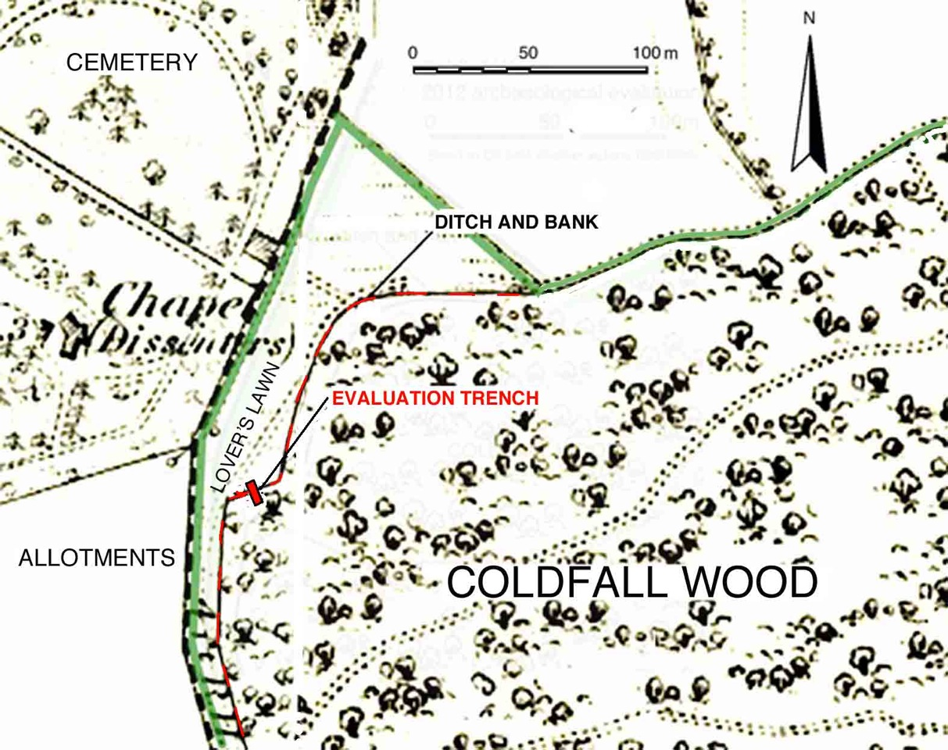

Fig 4: Location of evaluation trench.

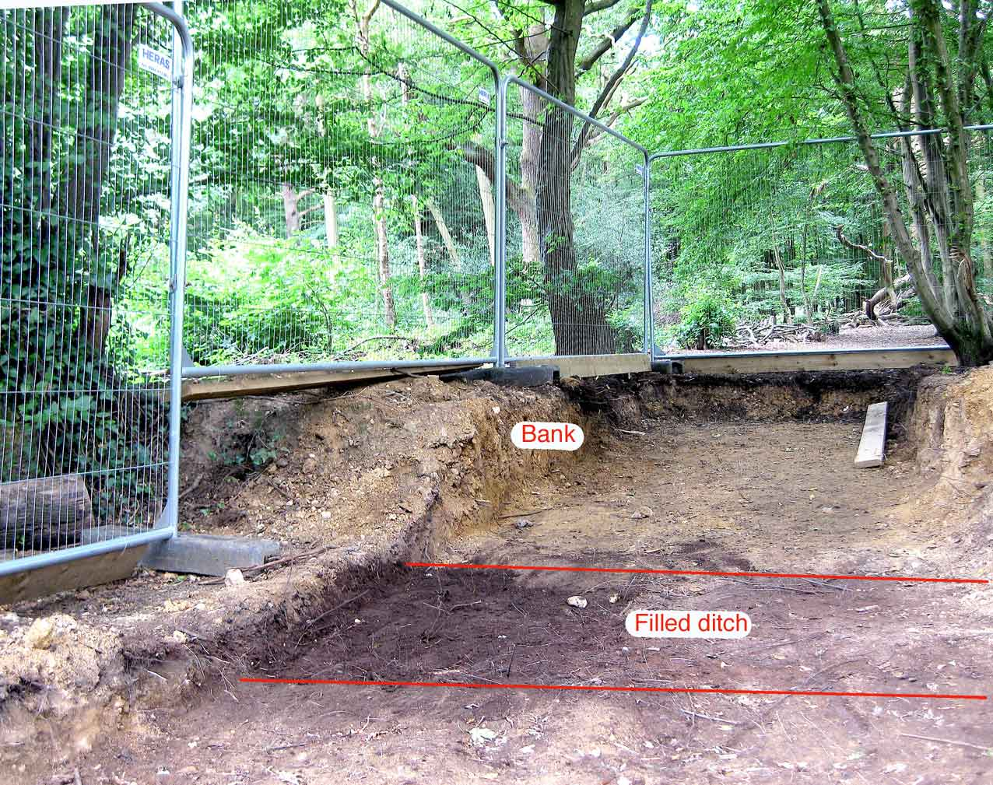

Fig 5: Machine cut trench across the ditch and bank prior to archaeological evaluation

Observations

The bank was surmounted by a variety of bushes and trees predominantly mature hornbeam (Carpinus) with occasional mature oak (Quercus sp.) and holly (Ilex sp.). Many of the hornbeams growing on the top of the bank lean towards the previously open common land to the west of the bank and are multi-stemmed, and gnarled. This indicates that they may at one time have been incorporated in a layered hedge. The ditch is visible as a shallow depression to the west of the bank (see Fig 5 and frontispiece).

Where the western part of the ditch and bank abuts the south eastern corner of Lover’s Lawn, the line of the bank veers to the N-E for approximately 20m before backing to the north to resume its N-S alignment.

Whatever the origins of this deviation, it forms an attractive position for a pedestrian ‘desire line’ path to cross the bank from Lover’s Lawn into the wood. As a result significant erosion of the bank had occurred at this point. The construction work had been commissioned to stabilise the ground and establish a more permanent path across the bank.

The bank was composed of a mid, yellowish brown, sandy/silty/clay matrix with occasional angular, rounded, and well-rounded pebbles, predominantly of flint and quartz, derived from the nearby Dollis Hill Gravel. There was a concentration of pebbles on the surface of the bank.

Some 50cm below the crest of the bank, a change in texture and compaction was observed. This was assumed to be a buried soil horizon (Fig 6). Soil samples were taken from above and below this horizon for particle analysis. This showed significant variation in the distribution of particle size. In particular, the sample from above the soil horizon contained a higher proportion of fine sand, silt and clay (c.83%) than the sample from below the horizon (c.54%).

A band of darker soil was observed in the western part of the machine cut, indicating a filled ditch. A trench c.50cm wide was excavated across the ditch to assess the composition of the ditch fill and the depth and profile of the ditch (Figs 5 and 6).

The surface of the ditch fill was c.60 cm below the crest of the bank and c.
1.50 m wide. In profile, the mid portion of the base of the ditch tended to flat. The edges were steeply sloping.

The maximum depth of the ditch fill was c.40cm. The lower part of the ditch fill was composed of a dark, blackish brown humic rich soil containing a small fraction of silty sand and clay (mor humus). The upper part of the ditch fill included a lens of dark, yellowish brown organic rich sandy silt up to c.20cm thick. This is interpreted as material eroded from the surface of the bank (see Fig 6) derived from natural weathering and erosion of the bank by pedestrian traffic. The selective removal of the finer material has lead to the concentration of pebbles observed on the surface of the bank. The ditch fill was colonised by a dense matt of tree roots.

A round cut c.10cm deep and 10cm in diameter was identified in the base of the ditch, close to the edge of the bank. This was provisionally interpreted as a posthole.

The base of the ditch was composed of firm, sandy/silt/clay with occasional flint pebbles similar to the material of the bank. This was assumed to be the undisturbed surface of the underlying head deposit.
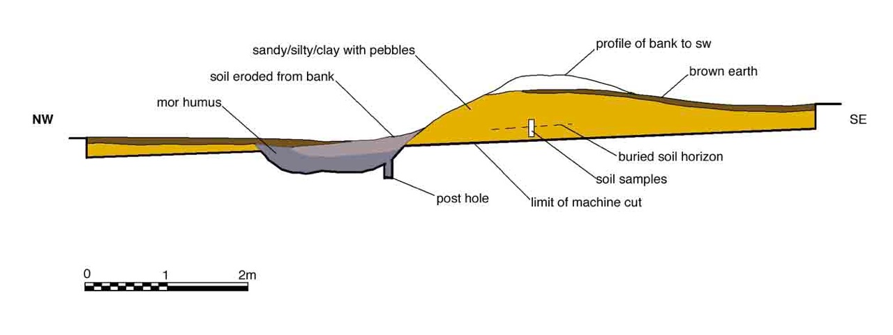

Fig 6: Section across the bank and ditch.

For comparative purposes, levels were surveyed on an unexcavated portion of the bank and ditch where the bank was less severely eroded, c.3.0m south-west of the trench. Here the crest of the bank was c.80cm above the surface of the ditch fill. The fill was probed with a hand auger and found to be c.40cm deep at this point, making the base of the ditch c.1.20m below the crest of the bank.

Thus the top of the bank would originally have been at least 1.20 m above the base of the ditch. A hedge or pale, perhaps 1m high would probably have surmounted the bank. This would have comprised a formidable barrier. The total height from the base of the ditch to the top of the hedge would have been over two meters. The ditch and bank feature is consistent with it being intended to protect the wood from deer. The Forestry Commission recommends a minimum height of 1.8m-2.0m for red deer fencing (Fig 7).

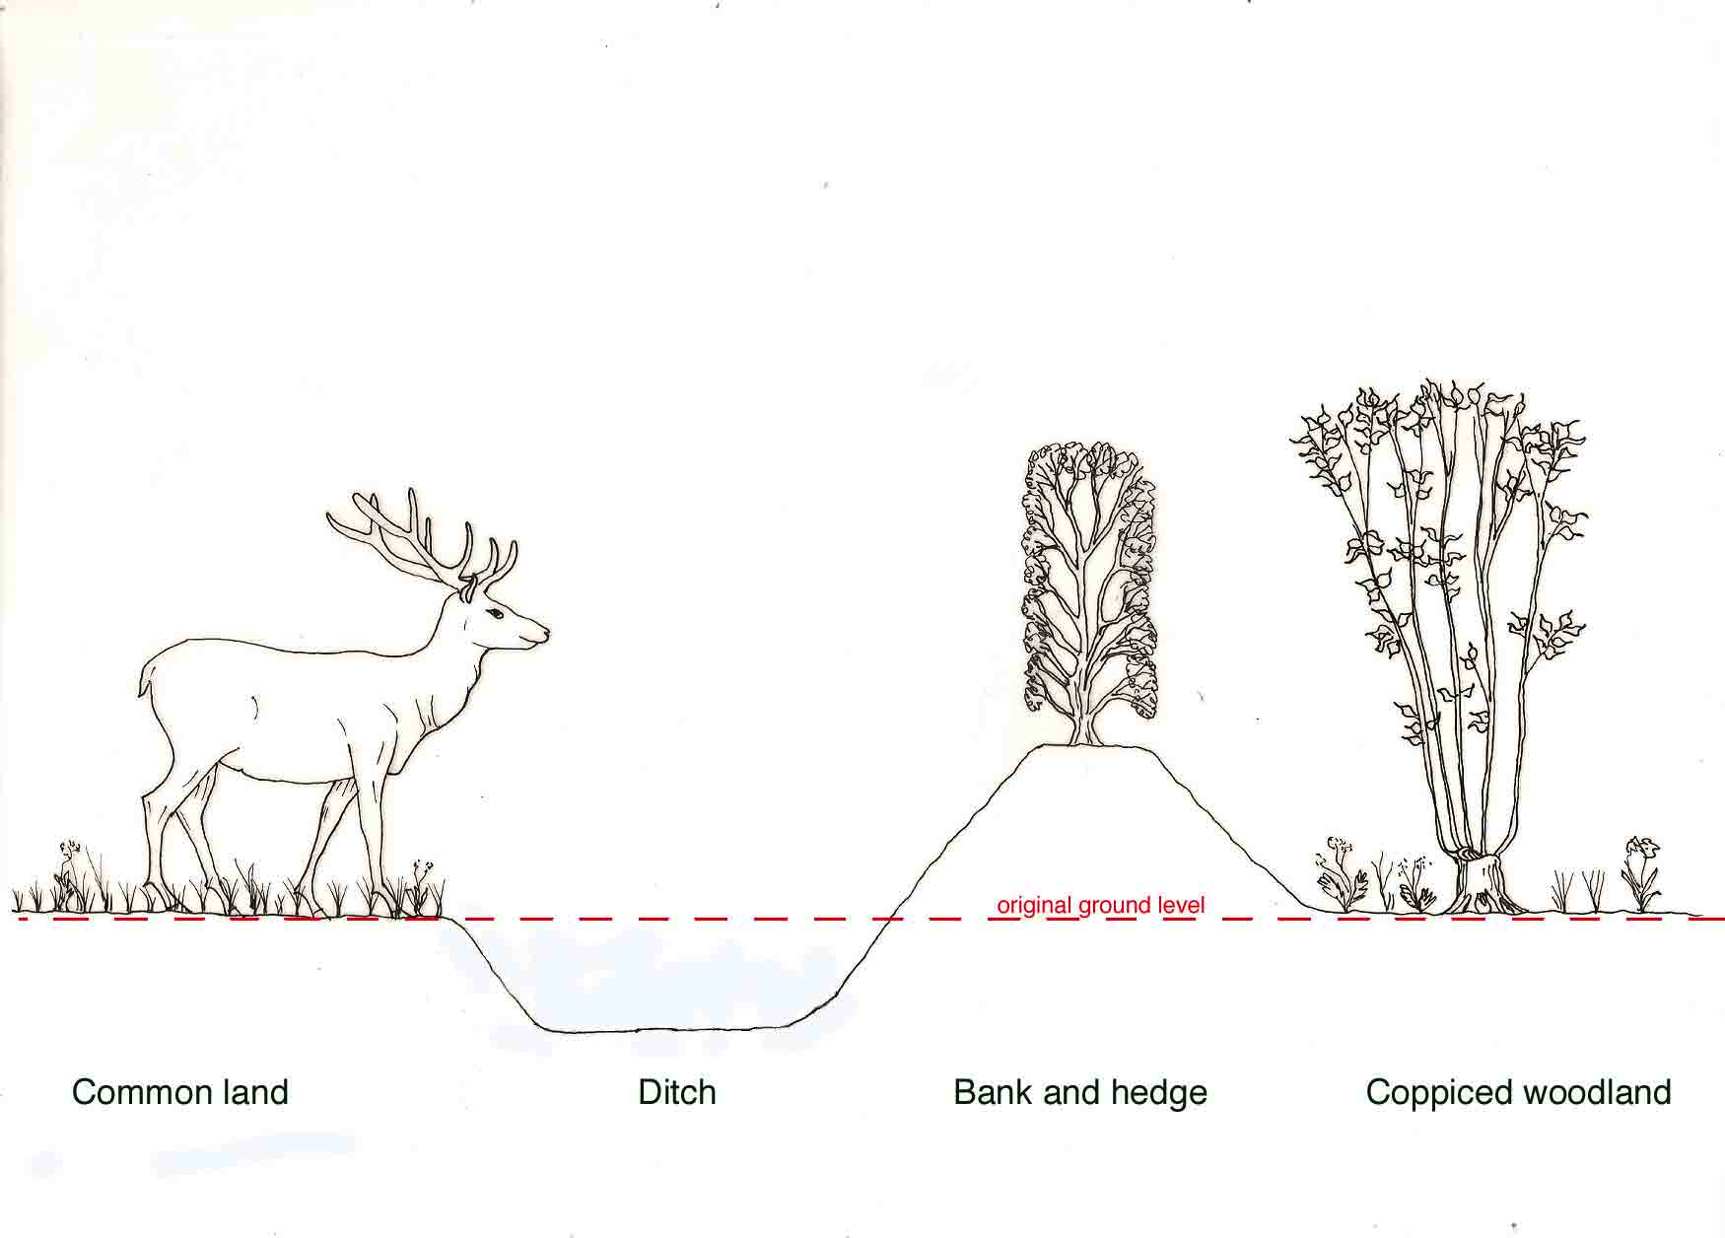
Fig 7: Hypothetical reconstruction of the ditch and bank derived from the archaeological investigations.

Artefacts.

Four fragments of glass were recovered from the base of the lower ditch fill. These were all from machine made bottles. They comprised: a thick, clear, natural green, bottleneck from a soda water bottle, possibly a bullet stoppered bottle; a thick (5mm) body fragment from a green champagne or other secondary fermented wine bottle; and a clear neck and a base fragment from an early form of milk bottle that would have been sealed by a card cap. No other artefacts were found.

The glass fragments have been dated to the late 19th or early 20th century. The then Hornsey Borough Council purchased Coldfall Wood in 1930. During the evaluation a local resident indicated that soon after it was acquired by the Borough Council the ditch had been cleared. The glass fragments may have been deposited at or soon after that time.

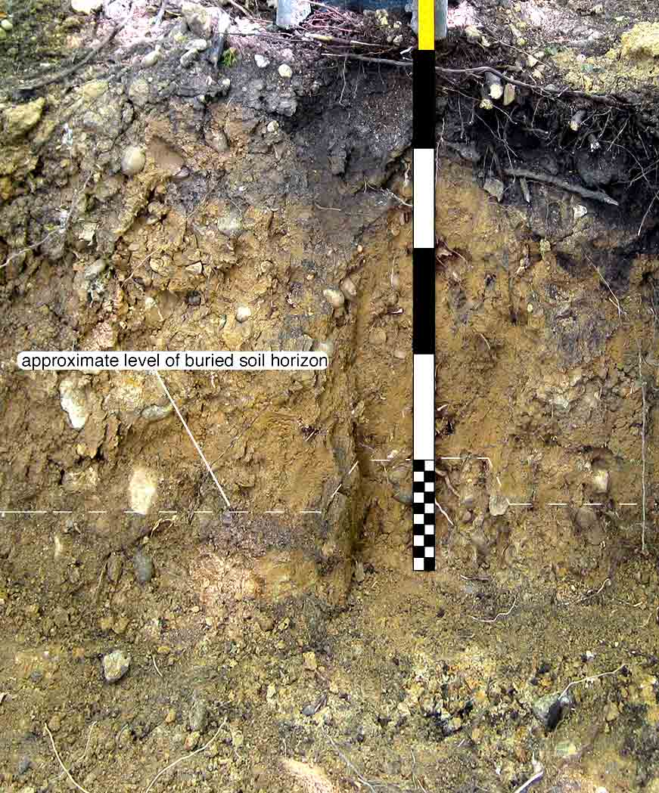

Fig 8: Part of SW face of the section through the bank showing location of soil samples and buried soil horizon.

Pollen analysis.

In addition to the soil samples taken for particle analysis (above) samples were taken from above and below the possible soil horizon for pollen analysis. Samples were taken at 5cm intervals from a 20 cm column (fig 8).

The following is an edited extract from a full report of the pollen analysis of samples obtained from both Coldfall Wood and the nearby Queen’s Wood by Professor Rob Scaife (University of Southampton).

Coldfall Wood; Linear bank palaeosol;

The profile has no visible old land surface in the form of an upper Ah horizon. Palynologically, an old land surface would be visible from high absolute pollen numbers at the top of the soils and with reduced numbers in the overlying/sealing bank. Expansion of absolute pollen values (apf) above 6cm are attributed to the modern soil development. There is, however, a minor expansion of apf values associated with changes in the palynology up to 14cm. This is thought to be the interface between the bank and the palaeosol although some truncation of the upper palaeosol has probably also occurred. Since its construction the make up of the bank has also been subject to pedalogical processes. This has progressively incorporated pollen in to the profile. The profile can thus be considered in two parts, the pre-bank palaeosol and the post bank vegetation soil development (see fig 9.).

Zone 1. The basal soil:
Hazel (Corylus avellana type) with oak (Quercus) are dominant (to 60% and 25% respectively). Other trees include only sporadic occurrences of birch (Betula), pine (Pinus) elm (Ulmus) and alder (Alnus) which are strong pollen producers and anemophilous (wind-pollinated). Beech (Fagus) and holly (Ilex) are, however, markedly under represented in pollen spectra (Andersen 1970, 1973) and their presence is significant. Hornbeam (Carpinus) is also present in small numbers (<1%). Ling (Calluna) is more abundant in this lower zone. Herbs are also relatively important with grasses (Poaceae - to c. 15%) with dandelion type (Lactucoideae - av. 5%) and a range of other less abundant taxa of mostly grassland/pasture affinity. There are however, also occasional cereal pollen. Ferns are represented but spore numbers are not high with bracken (Pteridium aquilinum), wood ferns (Dryopteris type) and common polypody fern (Polypodium vulgare).

Zone 2. The bank
Pollen within this upper zone comprises what is though to be the bank sealing the old land surface. As such it is expected that the pollen will derive from the soil from which the bank was constructed and pollen, which, through subsequent pedalogical processes, was incorporated into the soil. This may be reflected by the lower apf values in the basal part of the zone (7-13cm) with lower apf values and higher values above this from post construction pedogenic development.
Overall, the pollen taxa of zone 2 resemble those of zone 1 with fluctuations in percentage values and the changing absolute pollen numbers giving rise to the zonation/division. Oak (Quercus) and hazel (Corylus avellana type) remain the dominant arboreal taxa although there are increases of the former and reductions of the latter in this zone. There is, however, an expansion of hornbeam (Carpinus - to 6%). The herb pollen flora remains as in zone 1, that is, dominated by grasses (Poaceae) with slightly higher values (to ca. 30%). Ferns remain with bracken (Pteridium) increasing from zone 1 to 7%).

The vegetation
Because the top of the old land surface is not present, probably having been truncated, it is not possible to determine what the on-site vegetation was at the time of construction. However, the general uniformity of taxa in both pollen assemblage zones suggests that oak and hazel woodland with beech, and holly was important throughout the period represented. This probably represents managed woodland, probably coppice with standards with an understory of hazel. Beech was probably also a local component. Hornbeam is present in small numbers in the old soil profile (zone1) but with consistent occurrence. However, there is the possibility that there has been some downward transport from zone 2 above where there are higher numbers.
The pollen spectra also suggest that other habitats were present. Ling (Calluna) and sporadic heather (Erica) pollen indicate areas of possible heathland possibly within open areas of the woodland. Clearly, however, the dominance of grasses and the dandelion types (Lactucoideae) with ribwort plantain (Plantago lanceolata) and scabious (Scabiosa) amongst other taxa, indicates that there was grassland, probably, pasture nearby. Small numbers of cereal pollen are present, also showing arable activity and thus a mixed agricultural economy. This therefore raises the possibility that the bank and ditch may have been a boundary between contrasting managed woodland and open agricultural land.

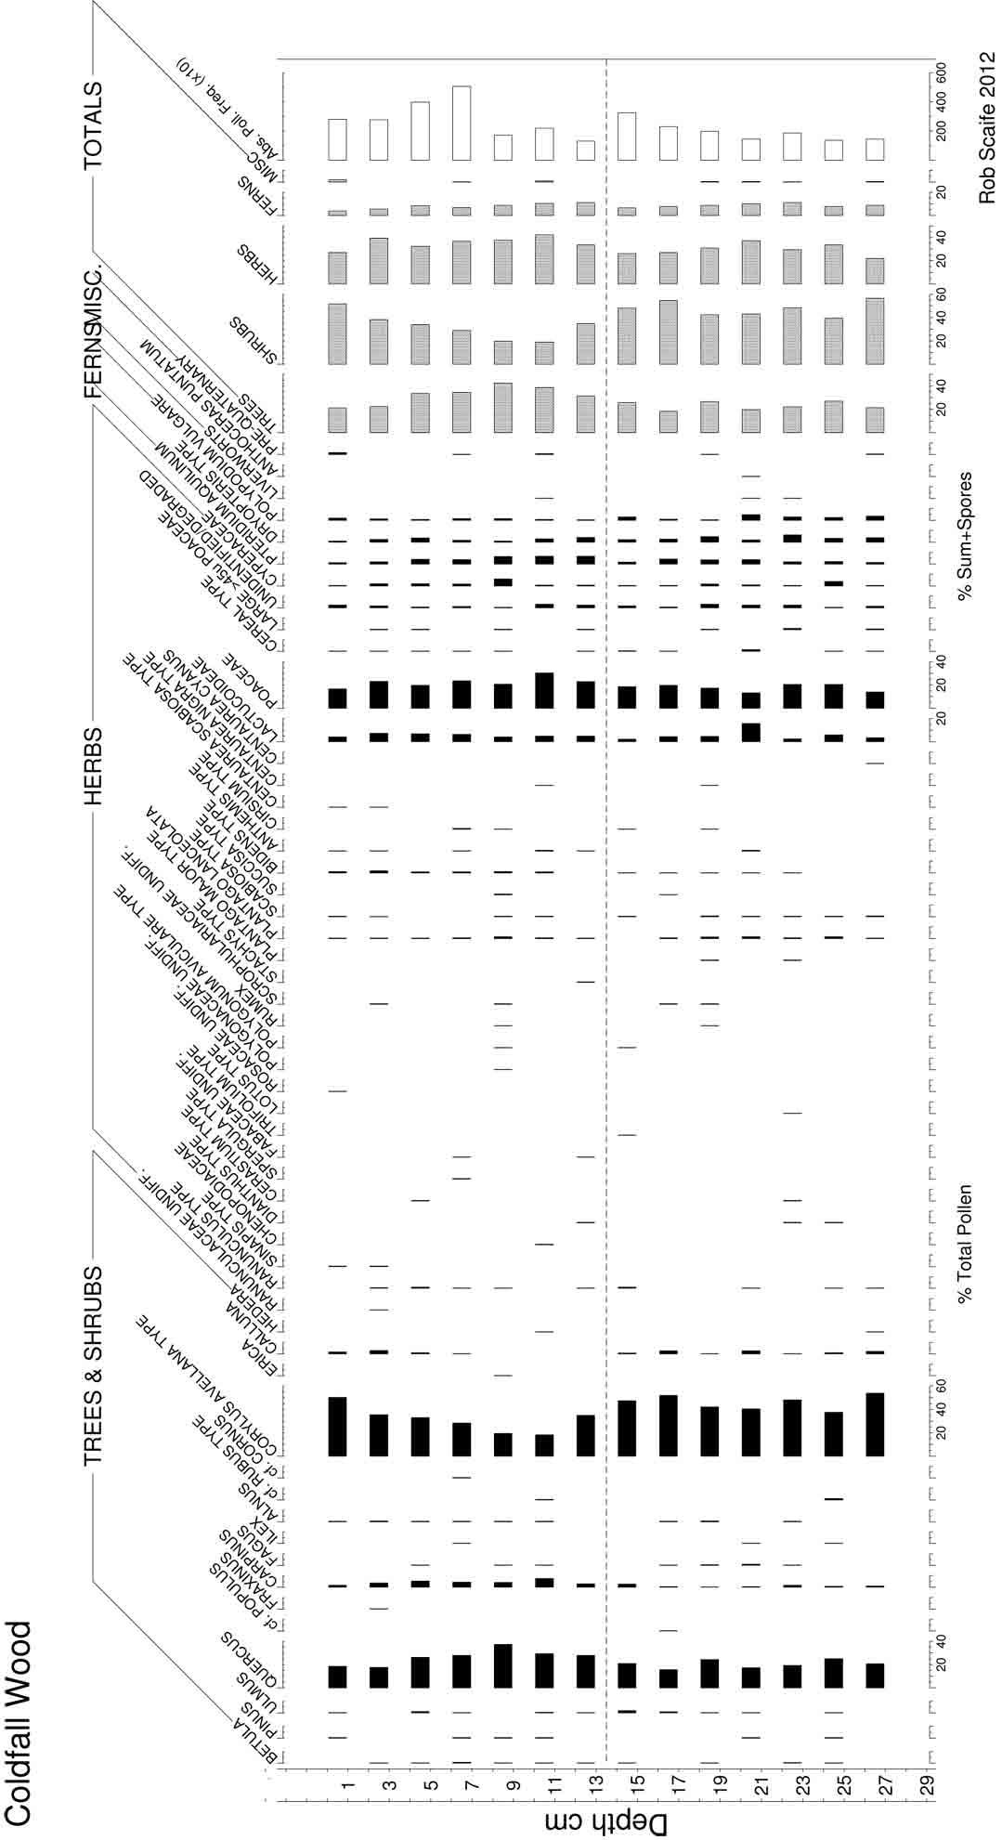

Fig 9: Pollen diagram (Scaife 2012)

Dating

The dating of archaeological contexts is a key aspect of interpreting any archaeological site. It is rarely possible to establish with certainty an exact calendar date and the archaeologist needs to assess evidence from a number of different sources to establish the most likely date for a particular context.

Pollen analysis is not in itself a means of dating an archaeological context and it was not possible to date the boundary bank directly. However, comparison of the pollen analysis of samples taken from Coldfall Wood with the pollen analysis of samples taken from under a boundary bank in the nearby Queen’s Wood revealed a similar pollen profile. This indicates that both banks were constructed at about the same time.

These two pollen profiles matched part of a pollen profile obtained from a deep, dated, waterlogged deposit in Queen’s Wood. Radiocarbon analysis of a fragment of twig from this part of the deposit gave a date range of between 1490 and 1630 AD (95% probability). Within this broad range there was a reasonable possibility (68% probability) that the bank was constructed between 1522 and 1576 AD. This supports the documentary evidence (above) that the ditch and bank boundary was built to enclose the wood after judgment was made in favour of the bishop in 1562. The single posthole located under the ditch during the evaluation may indicate that the wood had been enclosed at an earlier date by a fence and that the bank and ditch boundary was constructed to replace it.

Discussion

The pollen analysis shows that there have been radical changes in the nature of the woodland and the surrounding landscape since the construction of the enclosing bank. At the time of writing (2020), much of Coldfall Wood is dense, closed canopy deciduous woodland, dominated by mature hornbeam (Carpinus) and oak (Quercus) together with a wide variety of herbs and ferns associated with ancient woodland. In a botanical survey of the wood in 1985-1986 Bevan identified 13 main species of deciduous trees; maple (Acer), horse chestnut (Aesculus), birch (Betula), hornbeam (Carpinus), hazel (Corylus) hawthorn (Crataegus), beech (Fagus sylvatica), ash (Fraxinus), holly (Ilex), crabapple (Malus), oak (Quercus), wild service tree (Sorbus), yew (Taxus). Of these, hazel (Corylus avellana), ash (Fraxinus excelsior) and beech (Fagus sylvatica) are all rare in the present woodland. Of the 219 species of flowering plants, eighteen were identified as ancient woodland indicator species.

The dominant representation of oak and hazel in the pollen of the bank, together with the wide variety of herbs and grasses and the under-representation of hornbeam and other tree species and herbs associated with ancient woodland, is significant.

The pollen analysis indicates that at the time the bank was constructed in the mid 16th century the woodland was not dense, closed canopy woodland dominated by hornbeam and oak, but semi-open, managed woodland, dominated by hazel with oak standards. The evidence from the herb pollen indicates the proximity of open heath and grassland together with land used for cereal cultivation. The similarities between the samples from both the bank and the buried soil indicate that this mix of woodland and open landscape existed prior to and after the construction of the bank.

Conclusions

The evaluation has confirmed that bank and ditch were constructed to enclose the wood in order to exclude grazing animals and trespassers in the mid 16th century, probably during or shortly after 1562.

The material of the bank was obtained from superficial head deposits, derived from the Dollis Hill Gravel and the underlying London clay.

At the time the wood was enclosed it was open, woodland dominated by oak and hazel, probably managed as oak standards with an understory of coppiced hazel. Areas of open heath, meadowland and cultivated land existed adjacent to or in the woodland.

In view of the current dominance of hornbeam, it is significant that it is poorly represented in the pollen analysis, particularly in the buried soil under the bank. This suggests that hornbeam was introduced after the bank was constructed and eventually became the dominant underwood. The documentary evidence suggests that it was coppiced to provide firewood and charcoal.

Suggestions for future work.

Further documentary and cartographic research might reveal additional information on the origin, development and purpose of the ditch and bank and its relationship to the present boundary of the wood.

Additional sampling of the buried soil under the ditch might isolate organic material suitable for radiocarbon (¹⁴C) dating.

The earlier names of the wood and the large number of coppiced Hornbeam stools suggest that the wood had been used in the past for charcoal production. Documentary and archaeological research might identify evidence for this.

It is possible that undisturbed, waterlogged, organic rich, deposits similar to those found in Queen’s Wood may exist in the wood. Geoarchaeological sampling of such deposits would provide additional evidence of the management of the wood in the past and the development of the woodland flora.

Acknowledgments

The author would like to thank the following for their advice and support:

Professor R.G Scaife (Visiting Reader in Palaeoecology, School of Geography, University of Southampton, Visiting Scholar, Macdonald Institute for Archaeological Research, University of Cambridge) carried out the pollen analysis of soil samples and provided invaluable advice and guidance.

Ian Holt, former Project Officer (Nature Conservation) London Borough of Haringey for his support. John Shepherd for providing advice on identifying and dating the glass fragments. David Bevan (Former Conservation Officer, London Borough of Haringey and Honorary Vice-President, London Natural History Society) for his advice on the botanical aspects of the evaluationto. Diana Clements, (Hon. Sec. Geologists’ Association, GA representative on the London Geodiversity Partnership) provided advice on the geology.

Michael Hacker
[Revised June 2020]

Bibliography

Aston M. (1985) Interpreting the Landscape, London.

Baker T F and Elrington C R. eds. (1980) Finchley; Introduction, A History of Middlesex: V.6 , London.

Bevan D (2011) Coppicing in Haringey’s Ancient Woodland, London Naturalist, 90, 55-81

Bevan D (1992) ‘The natural history of Haringey’s ancient woodlands’, Lon. Nat. 71, 9-20 (http://www.muswell-hill.com/muswell/history/woodland/ )

Brown A. E. and Sheldon H. L. (2018) The Roman Pottery Site in Highgate Wood: excavations 1966-78, Archaeopress Roman Archaeology, Oxford.

British Geological Survey (2006) North London England and Wales Sheet 256, Bedrock and superficial deposits 1:50,000, BGS

Catt J (ed.) (2010) Hertfordshire Geology and the Landscape, Herts Nat.Hist. Soc. Hertford.

Clements D. (2015) The Geology of Highgate and Queen’s Wood, J. Amat. Geo. Soc, 9. London (http://londongeopartnership.org.uk/reportsandresearch/#queens)

Clements D (2019) Beneath out feet: the geology of Coldfall Wood, unpublished information leaflet for The Friends of Coldfall Wood, Haringey.

Hacker M, Scaife R & French C. (2014) Queen’s Wood, a palaeoecological analysis of organic-rich deposits in ancient woodland, unpublished report for City of London Archaeological Trust.

Hacker M (2017) The History and Archaeology of Queen’s Wood, Friends of Queen’s Wood. (https://www.fqw.org.uk/Reports/history_amended%20july%202017.pdf)

Haringey Council (2012) Coldfall Wood Management Plan 2012 , L B Haringey, London.

Lees D (1998) Highgate Wood London N10, An Archaeological Earthwork Survey, MoLAS, London.

London Geodiversity Partnership (2012) London’s Foundations 2012, Mayor of London (http://www.londongeopartnership.org.uk/publications.html)

Marsh J (1984) An old boundary, Bul. Horns. Hist. Soc, V25, 7. London

Pickering D (1763) The statutes at large, Cambs

Rackham O (2003) The Illustrated History of the Countryside, London

Rose F (1999) Indicators of Ancient Woodland: the use of vascular plants in evaluating ancient woodlands for nature conservation. British wildlife ,10, 241-251.

Silvertown J (1978) the history of woodlands in Hornsey, London Naturalist 57, pp11-25

Stokes M (2006) The boundary of Hornsey parish with Finchley, Bul. Horns. Hist. Soc. V.46, 8-13

Trout R and Pepper H (2006) Forest fencing, Forestry Commission Technical Guide, Edinburgh.

VCR-Victorian County History; see Baker and Elrington

Walker H (1874) The Glacial Drifts of Muswell hill and Finchley, London, republished with postscript by Robinson E (1993), Jack Whitehead, London

MAPS

BGS (2006) North London England and Wales Sheet 256, Bed rock and superficial deposits 1:50,000

Hornsey Enclosure Map (1816), London

Milne T (1800) Thomas Milne’s land use map of London and environs in 1800. London.

Ordnance Survey (1873 and 1894 revisions) 6 inches = 1 mile, HMSO

Roque (1745/1754) Environs of London, London

Wyld J (c1872) A new topographical map of the County in the vicinity of London, London

Photograph: © Michael Hacker 2012
Hacker et al, 2014
Silvertown, 1978
Haringey 2012, p7
Bevan 1962.
Lyson 1762; Lloyd 1888; Madge 1938; Silvertown 1978; Stokes 1984.
VCR p140, fn 8. Guildhall MSS, 12386, 12399; Marcham & Marcham 1929, pp. xix-xxi
CER, VCH p154
Ibid box B 79.53
VCR Mdx 153- St Paul's MSS, Box A 62
VCH p.153
Stokes 2006, p8
Pickering, 1763, p. 208-216
The author has not been able to establish the meaning of ‘cooltes’. The reference to ‘hedging bills’ probably is a reference to bill hooks, a short, hooked cutting blade used for maintaining layered hedging and the cutting of coppiced round-wood.
VCR 1980, V.6 p38-55
Stokes 2006, p6.
Aston 1985, p.111-2; Colebourn, 1989, p.69; Rackham 2003, p.46.
Lees 1998 p.20, Brown & Sheldon, 2018, p.71.
Stokes 2006, p 8; Marsh 1984
Based on OS 6” to 1 mile. Middx, 1873, sheet XII NW (https://maps.nls.uk/view/1023459520) and sheet XI NE (https://maps.nls.uk/view/102345949) . Reproduced with the permission of the National Library of Scotland.
Milne 1800
http//www.theundergroundmap.com
Catt 2010
Brown & Sheldon, 2018, p.73
BGS 2006; London’s Foundations 2011.
Clements (2019), Clements 2015, BGS 2006
Bevan 1986 quoted in Haringey 2012, p7
Based on OS 6” to 1 mile. Middx, 1873, sheet XII NW (https://maps.nls.uk/view/102345952) and sheet XI NE (https://maps.nls.uk/view/102345949). Reproduced with the permission of the National Library of Scotland.
Photograph: © Michael Hacker 2012
Trout & Pepper 2006, p13 table 4
Drawing: © Michael Hacker 2019
John Shepherd pers. com. September 2012
Haringey 2012, p 8.
Photograph:© Michael Hacker 2012
Scaife, forthcoming
Scottish Universities Environmental Research Centre (17/01/2014). 849 +/- 29 BP; SUERC-49790 (GU32356)
2 standard deviations (2σ)
1 standard deviation (1σ)
This was shortly after Bishop Edmund Grindal (Bishop of London 1559-1570) had been appointed to the see.
Bevan 2011, p55, 70-76.

